**BIOE 507 Homework 1**

1. *Example of a protein showing its primary, secondary and tertiary structure*

*Hemoglobin A2 (Homo Sapiens)*

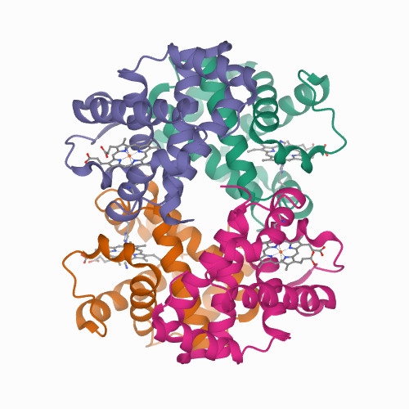

3D structure is from Protein Data Bank (https://www.rcsb.org/structure/1SI4)

The main function of hemoglobin is to carry oxygen through bloodstream. It could also bind with other molecules such as nitric oxide. Hemoglobin protein has 4 tertiary structure protein chains which are all alpha helics, 6 major and 2 short in each subunit. Each subunit has a ring-shaped structure called heme group which contains an iron atom that binds to oxygen molecule.

**Reference:**

<https://en.wikipedia.org/wiki/Hemoglobin>

1. *A catalyzed reaction for kinase phosphorylation. What’s its relevance in medicine?*

Protein kinase catalyzes a covalent addition of phosphate to target protein, playing a major role in regulating cellular activities. For example, Bcr-Abl tyrosine kinase is a tyrosine kinase that has a binding site for ATP to transfer the terminal phosphate from the ATP to the tyrosine residues on its substrates including [GRB2](https://en.wikipedia.org/wiki/GRB2) and [SHC.](https://en.wikipedia.org/wiki/SHC1) In chronic myelogenous leukemia, the Philadelphia chromosome leads to a fusion protein of abl with bcr that is a continuously active tyrosine kinase. Imatinib, or Gleevec, is the inhibitor of bcr-abl by occupying the tyrosine kinase active site. Some tumor cells depend on the bcr-abl. So inhibition of Bcr-Abl tyrosine kinase would deactivate its capability to perform its normal anti-apoptopic function, leading to the death of tumor cells.

**Reference:**

<https://en.wikipedia.org/wiki/Imatinib>

1. *Give an example of a cofactor and a co-enzyme catalyzed reaction.*

Coenzymes are usually non-protein organic molecules and cofactors are metallic ions. Both are required for some enzymes’ normal activity. In citric acid cycle, pyruvate dehydrogenase is a multienzyme complex that requires 4 coenzymes including thiamine pyrophosphate (TPP), lipoamide, FAD, NAD+, and coenzyme A (CoA) and 1 cofactor, magnesium ion. It catalyzes irreversible oxidative decarboxylation of pyruvate to form acetyl-CoA as the following reaction: Pyruvate+CoA+NAD+→acetyl CoA + CO2 + NADH +H+.

**Reference:** <https://en.wikibooks.org/wiki/Structural_Biochemistry/Krebs_Cycle_(Citric_Acid_cycle)>

<https://en.wikipedia.org/wiki/Cofactor_(biochemistry)#cite_note-7>

1. *What are the key surface proteins for SARS-CoV19 and illustrate its function.*

Spike (S) protein is the key surface protein of COVID-19 virus. It plays a major role in receptor recognition and cell membrane fusion process. S protein has 2 components, S1 and S2. S1 subunit has a receptor-binding domain that recognizes and binds to the host receptor angiotensin-converting enzyme 2. S2 subunit mediates viral cell membrane fusion by forming a six-helical bundle via 2 heptad repeat domain. The detailed mechanism is shown in the following figure.

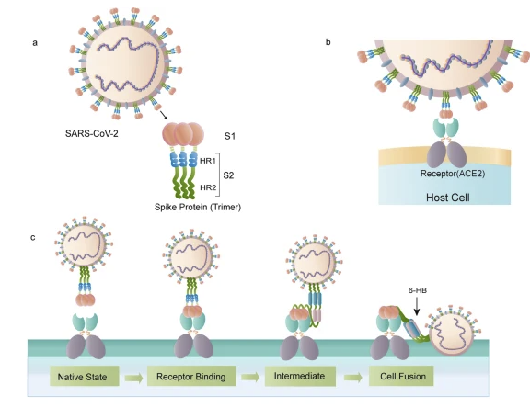

1. The schematic structure of the S protein. B. The S protein binds to the receptor ACE2. C. The binding and virus-cell fusion process mediated by the S protein.

**Reference:**

<https://www.nature.com/articles/s41401-020-0485-4>

1. *What’s the difference between antibody-based and mRNA-based therapy in the context of vaccination.*

Most vaccines are prophylactic, while some mRNA-based cancer vaccines are therapeutic. Both methods aim to trigger immune response to generate antibodies for antigen of encountered pathogen. Use virus as an example of pathogen, antibody-based vaccination is traditional vaccine that uses weakened virus or critical piece of virus’s protein coat containing the antigen. Once the first time the antigen is injected into the body, the immune system would learn to recognize it after the macrophages swallow the virus particles, and then the T-lymphocytes would learn to attack the cells infected with this virus and B-lymphocytes would produce specific antibody to attack the virus. After the infection, the body keeps a few memory T-lymphocytes and B-lymphocytes that reacts to the same virus quickly when it is encountered again. The antibody response is much more faster and effective this time due to the effect of memory cells.

The mRNA-based vaccine would synthesize the antigen in the body rather than injected directly. The injected mRNAs could be translated to make the protein piece on the virus surface. Once they are transported into the immune cells, the cells could use the mRNAs to make the antigen protein. After the protein is made, the mRNAs would be degraded which ensures the vaccine’s safety. When translated proteins appear on the surface of the cell, the immune system would recognize the antigen to trigger immune reaction. The detailed processes are same as described.

**Reference:**

<https://www.nature.com/articles/nrd.2017.243#Sec17>

<https://www.cdc.gov/coronavirus/2019-ncov/vaccines/different-vaccines/mrna.html>

1. *What are acetyltransferase and methyltransferase - state its role in gene regulation.*

Acetyltransferases are transferase enzymes that transfer an acetyl group to a substrate protein. For example, histone acetyltransferases (HATs) are enzymes that acetylate conserved lysine amino acids on histone proteins by transferring an acetyl group from acetyl-CoA to form ε-N-acetyllysine. Histone acetylation is linked to transcriptional activation. Acetylation of lysine neutralizes the positive charge normally present, reducing affinity between histone and DNA. It makes the DNA more accessible to transcription factors to cause transcriptional activation.

Methyltransferases are enzymes that methylate their substrates. For example, histone methyltransferases could modify lysine on the ε-nitrogen and arginine guanidinium group on histone tails via lysine methyltransferases and arginine methyltransferases. S-Adenosyl methionine (SAM) is the methyl donor for histone methylation. Up to 3 methyl groups could be modified on lysine amino acid while the number is 2 for arginine amino acid. This modification increases the strength of positive charge and residue hydrophobicity. The effect of methylation depends on the modification on the histone tail or other histone modification around it, including which amino acids are methylated and how many methyl groups are attached. Either increased or decreased transcription of genes around the modification can occur as as result of increased or decreased chromatin condensation.

**Reference:**

<https://en.wikipedia.org/wiki/Histone_acetyltransferase>

<https://en.wikipedia.org/wiki/Methyltransferase#Histone_methyltransferases>